**North Fork Elementary**

**School Advisory Council & School Advisory Forum Meeting Agenda**

**Tuesday, February 1, 2021**

**3:15 PM- Media Center**



1. **Roll Call to for Quorum/ Introductions**
2. **Approval of Minutes**
3. **School Mission & Vision**
4. **Principal Report**
5. **Mid-Year Review**
6. **School Accountability Funds (Balance- 8,822.99)**  (Accountability funds for student Incentives to reward student achievement)
7. **21st Century CCLC**
8. **Important Updates (BTU)**

**North Fork Elementary**

**School Advisory Council/ Parent Night**

**Tuesday, February 1, 2021**

**3:15 PM- School Advisory Council (Media)**

**5:00 – Parent Paint Night (Art Room)**

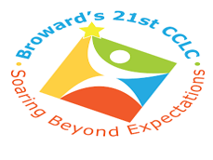

1. **Roll Call to for Quorum/ Introductions**
2. **School Mission & Vision**
3. **Principal Report**
4. **Mid-Year Review**
5. **21st Century CCLC**
6. **Important Updates**
7. **Student and Parent Paint Night (5:00 p.m.)**